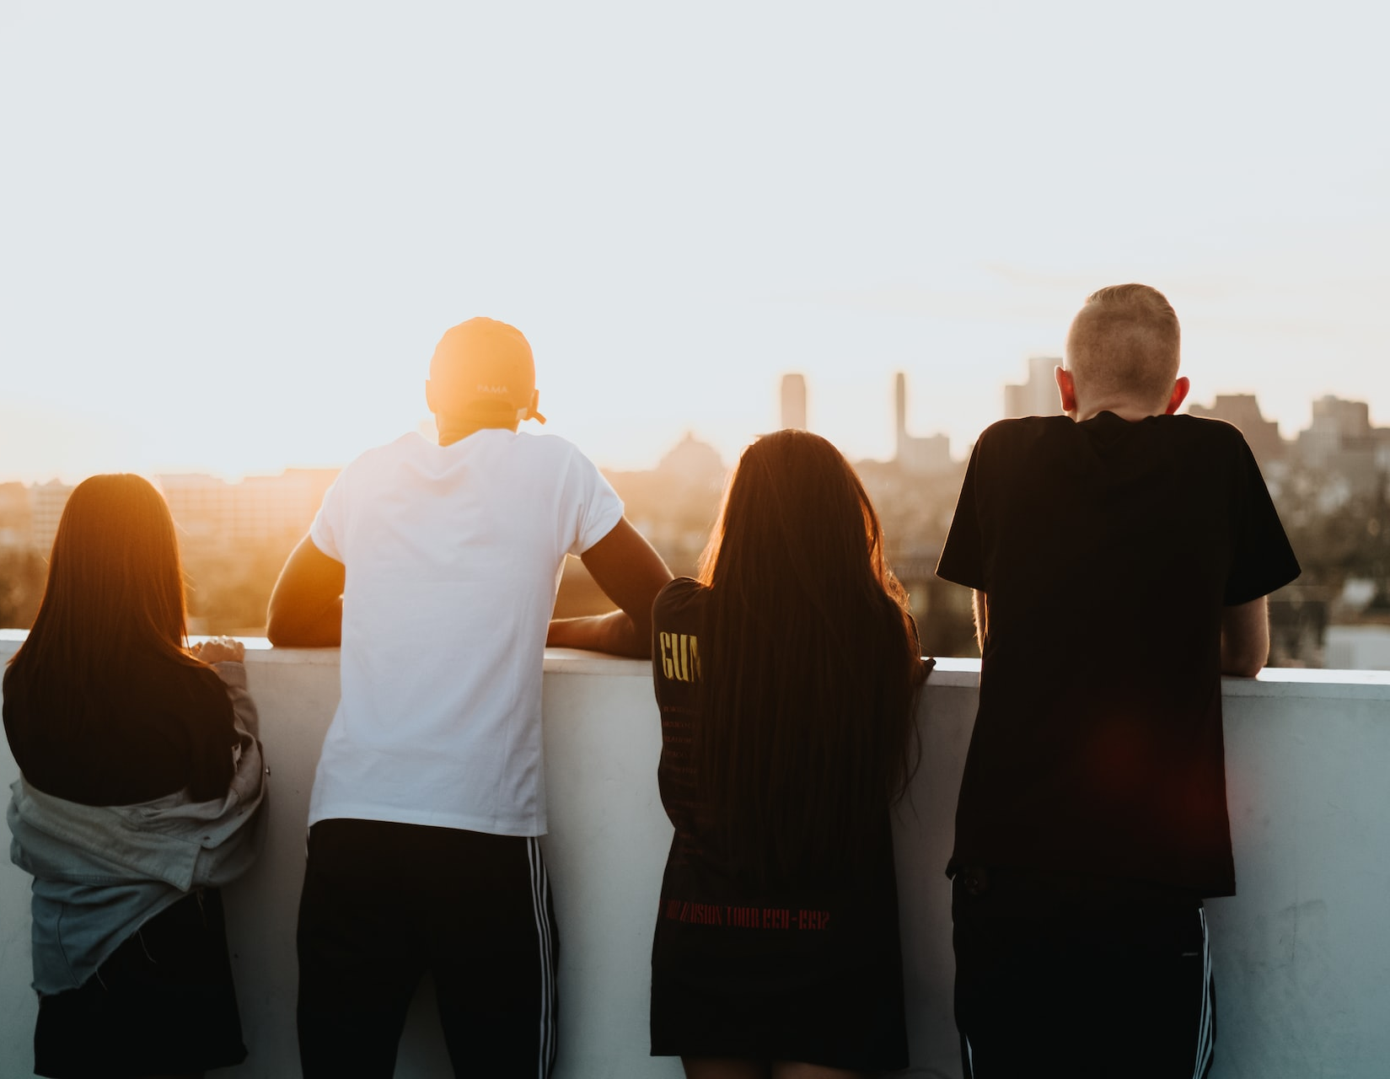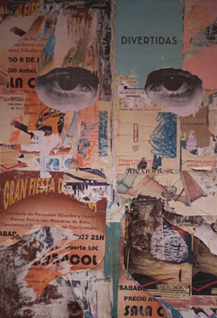  Art Journalling for youth who have experienced loss  Feeling alone? Don’t know where to turn?  Whatever type of life transition or loss you’ve experienced, there is no right or wrong way to grieve. Join with us and your peers In Person to find ways to express and work through your feelings in creative ways to heal and improve your physical, mental, emotional, and social well-being.  Date/Time: 8 Thursday evenings, 6:30 – 8:00pm  October 6 ,13 & 27, November 3, 10 & 24, December 1 & 8, 2022  Facilitator: Pattie Ann Pryma RN PhD PMATD Art Therapist  To Sign Up or for More Information Contact: Pattie Ann Pryma  (403) 852-5267 or email ppryma@youcreate.cc  Sponsored by: Solace Grief Support Society  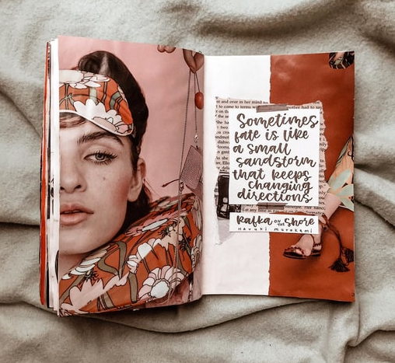  Solace Grief Support Society www.solacegriefsupport.com  Society  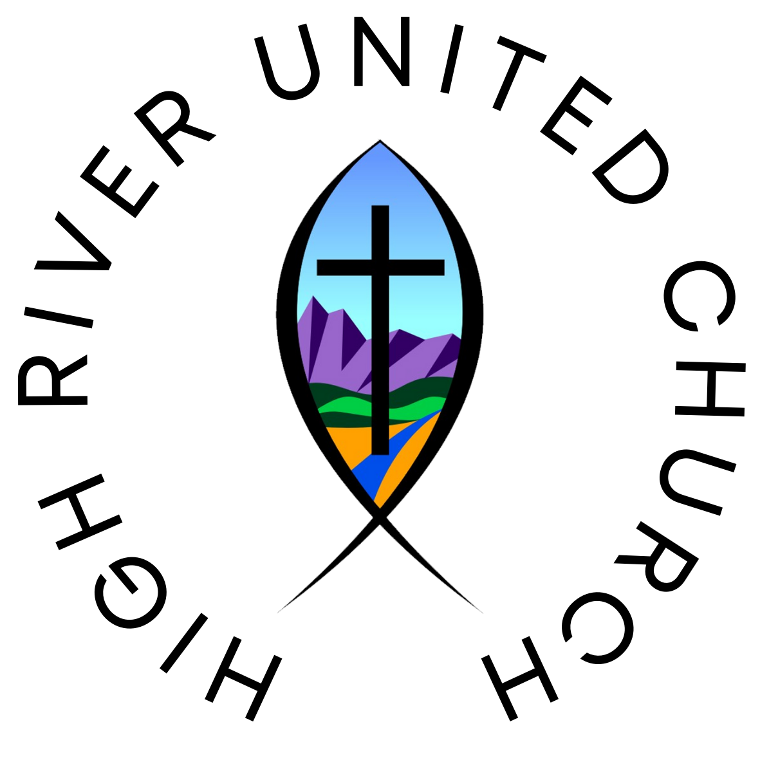 | Solace Grief Support Society  ____  You don’t have to go through this alone  ____  No Art Experience Needed  ____  For Youth 13 – 17 yrs  ____  It’s Free!!  Place to meet  Solace Grief Support Society Office in High River

